**JNANA SANGAMA, MACHHE BELAGAVI - 590018 KARNATAKA**



**A Mini-Project Report On**

## “POLITICAL SURVEY PORTAL ”

#### SUBMITTED IN PARTIAL FULFILLMENT OF THE REQUIREMENTS FOR THE WEB APPLICATIONS AND ITS TECHNOLOGY MINI PROJECT

**(18CS63) COURSE OF VIth SEMESTER**

Submitted by

**GAGAN KUMAR KR**

**[1CG20IS013]**

**PRAKASH AH**

**[1CG20IS033]**

### SURYA BS

**[1CG20IS044]**

**Guide: HOD:**

**Mr. Pradeep M M. Tech., Dr. Thara D K**

Asst. Prof., Dept. of ISE Head, Dept. of ISE

CIT, Gubbi. CIT, Gubbi.

### DEPARTMENT OF INFORMATION SCIENCE & ENGINEERING

**Channabasaveshwara Institute of Technology**

(Affiliated to VTU, Belgaum & Approved by AICTE, New Delhi) (**ISO 9001:2015 Certified Institution)**

NH 206 (B.H. Road), Gubbi, Tumkur – 572 216. Karnataka.

**2022-23**





### DEPARTMENT OF INFORMATION SCIENCE & ENGINEERING

**2022-23**

# CERTIFICATE

This is to certify that the project entitled **“POLITICAL SURVEY PORTAL”** has been successfully carried out by **GAGAN KUMAR KR[1CG20IS013], PRAKASH AH [1CG20IS033], SURYA BS[1CG20IS044]**, in partial fulfillment for the VI semester during the academic year **2022- 23**. It is certified that all the corrections / suggestions indicated for internal assessment have been incorporated in the report. The project report has been approved as it satisfies the academic requirements in respect of project work prescribed for the VI semester.

**Signature of guide Signature of HOD**

**Mr. Pradeep M M.Tech, Dr. Thara D K**

Asst. Prof., Dept. of ISE Head, Dept. of ISE

CIT, Gubbi. CIT, Gubbi.

**Signature of Principal Dr. Suresh D S**

Principal CIT, Gubbi.

**External Viva**

**Name of Examiners Signature with date**

1.

2.





**DEPARTMENT OF INFORMATION SCIENCE & ENGINEERING**

**2022-23**

**DECLARATION**

I am Gagan Kumar KR Surya BS Prakash AH students of VI Semester, **B E.,** in Information Science and Engineering**, C.I.T, Gubbi**, hereby declare that the dissertation work entitled **“COURSE MANAGEMENT SYSTEM”**, embodies the report of our project work carried out independently by us under the guidance of **Mr. Pradeep M**, Assistant Professor Department ISE, CIT, Gubbi, as partial fulfillment of requirementsfor the VI Semester during the academic year **2022-23**. I further declare that the projecthas not been submitted for the award of any other degree.

**Place: GUBBI GAGAN KUMAR KR**

**Date: [1CG20IS013]**

**PRAKASH AH [1CG20IS033]**

**SURYA BS**

**[1CG20IS044]**

# ABSTRACT

The Political Survey Portal is an innovative web-based platform designed to collect and analyze public opinion on political issues. In today's fast-paced and interconnected world, understanding public sentiment is crucial for policymakers, political parties, and researchers. The portal aims to bridge the gap between citizens and decision-makers by providing an accessible and user-friendly interface for conducting surveys and gathering valuable insights.

The Political Survey Portal leverages advanced technologies to create a seamless experience for participants, ensuring a high response rate and diverse representation. Users can easily create and distribute surveys tailored to specific political topics, target demographics, or geographic regions. The portal supports various question formats, including multiple-choice, open-ended, and rating scales, enabling comprehensive data collection and analysis.

.

# ACKNOWLEDGEMENT

A great deal of time and lot of effort has gone into completing this project report and documenting it. The number of hours spent in getting through various books and other materials related to this topic chosen by we have reaffirmed its power and utility in doing this project.

Several special people have contributed significantly to this effort. First, we aregrateful to our institution **Channabasaveshwara Institute of Technology**, Gubbi, which provides us an opportunity in fulfilling our most cherished desire of reaching the goal.

We acknowledge and express our sincere thanks to our beloved Principal and Director (Tech.)**Dr. Suresh D S** for his many valuable suggestions and continuous encouragement and support in the academic endeavours.

We express our sincere gratitude to **Dr. Shantala C P,** Vice Principal& Head, Department of CSE, for providing his constructive criticisms and suggestions.

Thanks to **Dr. Thara D K** head of the Department of Information Science and Engineering for his guidance on how to approach an engineering problem and come up with a solution in an organized manner.

We wish to express our deep sense of gratitude to **Mr. Pradeep M,** Department of Information Science and Engineering for all the guidance and who still remains a constant driving force and motivated through innovative ideas with tireless support and advice during the course of project to examine and helpful suggestions offered, which has contributed immeasurably to the quality of the final report.

# CONTENTS

### ABSTRACT i

**ACKNOWLEDGEMENT ii**

|  |  |
| --- | --- |
| **CHAPTER** | **PAGE NO** |
| **1. INTRODUCTION** | **01** |
| **2. HISTORICAL REVIEW** | **02** |
| **3. REQUIREMENT SPECIFICATION**  **SYSTEM REQUIREMENTS HARDWARE CONFIGURATION SOFTWARE CONFIGURATION**  **DEVELOPMENT ENVIRONMENT NORMALIZATION** | **04**  **07**  **07**  **07**  **07**  **12** |
| 1. **SYSTEM IMPLEMENTATION MODULES DESCRIPTION CONTACT TABLE** 2. **DATA FLOW DIAGRAM** 3. **SAMPLE OUTPUT SCREENSHOTS HOME PAGE**   **LOGIN PAGE ADMIN PAGE**   1. **CONCLUSION** 2. **REFFERENCE** | **13**  **14**  **15**  **17**  **18**  **19** |

**CHAPTER 1 INTRODUCTION**

The purpose of the project **“Political Survey Portal”**, the manual work makes the process slow and other problems such as inconsistency and ambiguity on operations. In order to avoid this placement managed system is proposed, where the student information in the college with regard to placement is managed efficiently. It intends to help fast in fast access procedures in placement related activities and ensures to maintain the details of the student. Students logging should be able to upload their personal and educational information. The key feature of this project is that it is one time registration enabled. The placement cell calls the companies to select their students for jobs via the campus interview. The placement cell allows the companies to view the student resumes in selective manner. They can filter the students profile as per their requirement. The job details of the placed students will be provided by the administrator. The administrator plays an important role in our project. Our project provides the facility of maintaining the details of the students and gets the requested list of candidates for the company who would like to recruit the students based on given query.

Nowadays importance is given to the wireless technology and effective system. Computers and technology have become part of our life for accessing almost everything we basically do. The World Wide Web contributes enormously to the creation of an ever-increasing global information database. It could also be used as a system to share information within an enterprise. Placement management system helps the placement officers to overcome the difficulty in keeping records of hundreds and thousands of students and searching the eligible students for recruitment, based on various eligibility criteria of different companies. It helps in effective and efficient utilization of the hardware and the software resources. The students will create their accounts and the administrator will accept or reject their request. Based on the approval from administrator the students will be allowed to proceed further. The students will then enter their details which will be approved by administrator. Once approved, the students will get notified on every updates from TPO. They can also change their password and details if necessary in future. This gives quick visual confirmation of security and guarantees that redundancy will not be allowed, in fact, what was intended.

## CHAPTER 2 HISTORICAL REVIEW

### History of Political Survey

The history of political survey portals can be traced back to the development of survey research methods and the advent of the internet. Political surveys have long been used as a tool to gauge public opinion, understand voter preferences, and assess political trends. The introduction of online platforms revolutionized the way surveys were conducted, making them more accessible and efficient.

In the early days of the internet, political surveys were primarily conducted through email or on websites that required individuals to fill out forms. However, dedicated political survey portals began to emerge as technology advanced and online communication became more widespread.

### History of Database Management System

Following the technology progress in the areas of processors, computer memory, computer storage, and computer networks, the sizes, capabilities, and performance of databases and their respective DBMSs have grown in orders of magnitude. The development of database technology can be divided into three eras based on data model or structure: navigational, SQL/relational, and post-relational.[2] The two main early navigational data models were the hierarchical model, epitomized by IBM's IMS system, andthe CODASYL model (network model), implemented in a number of products such as IDMS.

The relational model employs sets of ledger-style tables, each used for a different type of entity. Only in the mid-1980s did computing hardware become powerful enough to allow the wide deployment of relational systems (DBMSs plus applications). By the early 1990s, however, relational systems dominated in all large-scale data processing applications, and as of 2015 they remain dominant: IBM DB2, Oracle, MySQL, and Microsoft SQL Server are the top DBMS.

The dominant database language, standardized SQL for the relational model, has influenced database languages for other data models.

### History of MySQL

MySQL is an open-source relational database management system (RDBMS). MySQL is written in C and C++. Its SQL parser is written in yacc, but it uses a home-brewed lexicalanalyzer. MySQL works on many system platforms, including Linux, macOS, Microsoft Windows, NetBSD. MySQL is offered under two different editions: the open source MySQL Community Server and the proprietary [Enterprise Server.](https://en.wikipedia.org/wiki/MySQL_Enterprise) MySQL Enterprise Server is differentiated by a series of proprietary extensions which install as server plugins, but otherwise shares the version numbering system and is built from the same code base.[1]

Major features that are available in MySQL are a broad subset of ANSI SQL 99,as well as extensions, Cross-platform support, [Stored procedures,](https://en.wikipedia.org/wiki/Stored_procedure) using a procedural language that closely adheres to [SQL/PSM](https://en.wikipedia.org/wiki/SQL/PSM), [Triggers, Cursors,](https://en.wikipedia.org/wiki/Database_trigger) Updatable [views, Online DDL](https://en.wikipedia.org/wiki/View_(SQL)) when using the InnoDB Storage Engine. Many programming languages with language-specific APIs include libraries for accessing MySQL databases. These include MySQL Connector/Net for integration with Microsoft's Visual Studio and the JDBC driver for Java. In addition, an ODBC interface called MySQL Connector/ODBC allows additional programming languages that support the ODBC interface to communicate with a MySQL database, such as ASP or ColdFusion.

## CHAPTER 3 REQIREMENT SPECIFICATION

### System Requirements

The basic requirements for the development of this mini project are as follows

#### Hardware Configuration

1. Processor: Intel core i3 or above
2. Ram:512 MB
3. Hard disk:20 GB

#### Software Configuration

* 1. Front end tool: HTML
  2. Back end tool: PHP
  3. Development tools: XAMPP server
  4. Browser: Google or any
  5. Documentation tool: Microsoft office 2003 or above

### Development Environment

#### Frontend-HTML

It is the standard [mark-up language](https://en.wikipedia.org/wiki/Markup_language) for creating [web pages](https://en.wikipedia.org/wiki/Web_page) and web applications. With [Cascading Style Sheets](https://en.wikipedia.org/wiki/Cascading_Style_Sheets) (CSS) and [JavaScript](https://en.wikipedia.org/wiki/JavaScript), it forms a triad of [cornerstone](https://en.wikipedia.org/wiki/Cornerstone) technologies for the [World Wide Web. Web browsers](https://en.wikipedia.org/wiki/World_Wide_Web) receive HTML documents from a [web server](https://en.wikipedia.org/wiki/Web_server) or from local storage and render the documents into multimedia web pages. HTML describes the structure of a web page [semantically](https://en.wikipedia.org/wiki/Semantic_Web) and originally included cues for the appearance of the document.HTML can embed programs written in a [scripting language](https://en.wikipedia.org/wiki/Scripting_language) such as [JavaScript](https://en.wikipedia.org/wiki/JavaScript), which affects the behaviour and content of web pages. Inclusion of CSS defines the look and layout of content. The [World Wide Web Consortium](https://en.wikipedia.org/wiki/World_Wide_Web_Consortium) (W3C), maintainer of both the HTML and the CSS standards, has encouraged the use of CSS over explicit presentational HTML since 1997.

#### Backend-MySQL

Itis an open-source relational database management system (RDBMS).The MySQL development project has made its source code available under the terms of GNU General Public License, as well as under a variety of proprietary agreements. MySQL was owned and sponsored by a single for-profit firm, the Swedish company MySQL AB, now owned by Oracle Corporation. For proprietary use, several paid editions are available, and offered additional functionality. MySQL is central component of LAMP open-source web application software stack. LAMP is an acronym of “Linux, Apache, MySQL, Perl/PHP/Python”. Applications that use the MySQL database include TTPO3, MODx, Joomal, WordPress, phpBB, MyBB, and Drupal. MySQL is also used in many high-profiles. Large-scale websites, including Google, Facebook, Twitter, Flickr, YouTube.

#### PHP

PHP is a server-side scripting language designed for web development but also used as a general-purpose programming language. PHP is now installed on more than 244 million websites and 2.1 million web servers. Originally created by Rasmus Lerdorf in 1995, the reference implementation of PHP is now produced by The PHP Group. While PHP originally stood for Personal Home Page, it now stands for PHP: Hypertext Preprocessor, a recursive back ronym. PHP code is interpreted by a web server with a PHP processor module, which generates the resulting web page: PHP commands can be embedded directly into an HTML source document rather than calling an external file to process data. It has also evolved to includea command-line interface capability and can be used in standalone graphical applications. PHP is free software released under the PHP License. PHP can be deployed on most web servers and also as a standalone shell on almost every operating system and platform, free of charge.

#### APACHE

The Apache HTTP Server is a webserver software not able for playing a key role in the initial growth of the World Wide Web. In 2009 it became the first webserver software to surpass the 100 million web site milestone .Apache is developed and maintained by an open community of developers under the auspices of the Apache Software Foundation. Since April 1996Apachehasbeenthe most popular HTTP servers of software in use. As of November 2010 Apache serve dover 59.36% of all websites and over 66.56% of the first one million busiest websites.

#### XAMPP

XAMPP is a small and light Apache distribution containing the most common web development technologies in a single package. Its contents, small size, and portability make it the ideal tool for students developing and testing applications in PHP and MySQL. XAMPP is available as a free down load in two specific packages: full and lite. Whilethe full package download provides a wide array of development tools, XAMPPL it contains the necessary technologies that meet the Ontario Skills Competition standards. The light version is as mall package containing Apache HTTP Server, PHP, MySQL, phpMyAdmin, Open sql, and SQLite.

Operating System Windows 10

|  |  |
| --- | --- |
| [Screenshot](https://en.wikipedia.org/wiki/Screenshot) of the default MySQL command-line banner and prompt | |
| **[Original author(s)](https://en.wikipedia.org/wiki/Software_developer)** | [MySQL AB](https://en.wikipedia.org/wiki/MySQL_AB) |
| **[Developer(s)](https://en.wikipedia.org/wiki/Software_developer)** | [Oracle Corporation](https://en.wikipedia.org/wiki/Oracle_Corporation) |
| **Initial release** | 23 May 1995; 22 years ago |
| **[Stable release](https://en.wikipedia.org/wiki/Software_release_life_cycle)** | 5.7.20[[1]](https://en.wikipedia.org/wiki/MySQL" \l "cite_note-mysql_release-1)/ 16 October 2017; 37 days ago |
| **[Preview release](https://en.wikipedia.org/wiki/Software_release_life_cycle)** | 8.0.3 rc[[2]](https://en.wikipedia.org/wiki/MySQL" \l "cite_note-2)/ 21 September 2017; 2 months ago |
| **[Repository](https://en.wikipedia.org/wiki/Repository_(version_control))** | [https://github.com/mysql/mysql-](https://github.com/mysql/mysql-server)  [server, git://anongit.gentoo.org/proj/mysql-](https://github.com/mysql/mysql-server) [extras.git](git://anongit.gentoo.org/proj/mysql-extras.git) |

|  |  |
| --- | --- |
| **Development status** | Active |
| **Written in** | [C, C++](https://en.wikipedia.org/wiki/C_(programming_language))[[3]](https://en.wikipedia.org/wiki/MySQL" \l "cite_note-3) |
| **[Operating system](https://en.wikipedia.org/wiki/Operating_system)** | [Windows, Linux,](https://en.wikipedia.org/wiki/Microsoft_Windows) [Solaris, macOS,](https://en.wikipedia.org/wiki/Solaris_(operating_system)) [FreeBSD](https://en.wikipedia.org/wiki/FreeBSD)[[](https://en.wikipedia.org/wiki/FreeBSD)4] |
| **Available in** | [English](https://en.wikipedia.org/wiki/English_language) |
| **[Type](https://en.wikipedia.org/wiki/Software_categories" \l "Broad_categories)** | [RDBMS](https://en.wikipedia.org/wiki/Relational_database_management_system) |
| **[License](https://en.wikipedia.org/wiki/Software_license)** | [GPL](https://en.wikipedia.org/wiki/GNU_General_Public_License) (version 2) or [proprietary](https://en.wikipedia.org/wiki/Proprietary_software)[[5]](https://en.wikipedia.org/wiki/Proprietary_software) |
| **Website** | [www.mysql.com](http://www.mysql.com/) |

#### Fig 3.1 MySQL

|  |  |
| --- | --- |
| XAMPP | |
|  | |
| **Fig 3.2 A screenshot of XAMPP running all servers onMac OS X** | |
| **[Developer(s)](https://en.wikipedia.org/wiki/Software_developer)** | Apache Friends |
| **Initial release** | May 22, 2002; 15 years ago |



**[Stable release](https://en.wikipedia.org/wiki/Software_release_life_cycle)** 7.1.11 - [Windows](https://en.wikipedia.org/wiki/Microsoft_Windows)

7.1.11 - [Linux](https://en.wikipedia.org/wiki/Linux)

7.1.11 - [macOS](https://en.wikipedia.org/wiki/MacOS) / November 10, 2017; 7 days ago

**[Repository](https://en.wikipedia.org/wiki/Repository_(version_control))** <https://github.com/ApacheFriends>

**Development status** Active

**Written in** Various Languages

**[Operating system](https://en.wikipedia.org/wiki/Operating_system)** [Cross-platform](https://en.wikipedia.org/wiki/Cross-platform)

[Linux](https://en.wikipedia.org/wiki/Linux) [Windows](https://en.wikipedia.org/wiki/Microsoft_Windows) [Solaris](https://en.wikipedia.org/wiki/Solaris_(operating_system)) [macOS](https://en.wikipedia.org/wiki/MacOS)

**[Platform](https://en.wikipedia.org/wiki/Computing_platform)** [Windows](https://en.wikipedia.org/wiki/Microsoft_Windows) - [2008, 2012,](https://en.wikipedia.org/wiki/Windows_Server_2008) [Vista, 7,](https://en.wikipedia.org/wiki/Windows_Server_2012) [8, 10](https://en.wikipedia.org/wiki/Windows_8) x32 Bit [Linux](https://en.wikipedia.org/wiki/Linux) -

[Debian, RedHat,](https://en.wikipedia.org/wiki/Debian) [CentOS, Ubuntu,](https://en.wikipedia.org/wiki/CentOS) [Fedora, Gentoo,](https://en.wikipedia.org/wiki/Fedora_(operating_system)) [Arch, SUSE](https://en.wikipedia.org/wiki/Arch_Linux) x32 or x64 Bit

[macOS](https://en.wikipedia.org/wiki/MacOS) - [10.6](https://en.wikipedia.org/wiki/Mac_OS_X_Snow_Leopard) or later x64 Bit

**[Size](https://en.wikipedia.org/wiki/File_size)** [Windows](https://en.wikipedia.org/wiki/Microsoft_Windows) x32 Bit - 120 Mb

[Linux](https://en.wikipedia.org/wiki/Linux) x64 Bit - 137 Mb [macOS](https://en.wikipedia.org/wiki/MacOS) x64 Bit - 137 Mb

**Available in** 11 languages

[[show]](https://en.wikipedia.org/wiki/XAMPP)

**List of languages**

**[Type](https://en.wikipedia.org/wiki/Software_categories" \l "Broad_categories)** [WAMP, MAMP,](https://en.wikipedia.org/wiki/WAMP) [SAMP, LAMP](https://en.wikipedia.org/wiki/SAMP_(Sun_Web_Stack))

**[License](https://en.wikipedia.org/wiki/Software_license)** [GNU General Public Licence](https://en.wikipedia.org/wiki/GNU_General_Public_License)

**[Alexa](https://en.wikipedia.org/wiki/Alexa_Internet) rank** 10,525[[1]](https://en.wikipedia.org/wiki/XAMPP" \l "cite_note-1)

**Website** [apachefriends.org](https://www.apachefriends.org/)

## Normalization

Normalization is a process of organizing the data in database to avoid data redundancy, insertion anomaly, update anomaly & deletion anomaly. To overcome these anomalies, we need to normalize the data. There are 4 basic types of normalizations. They are:

* First normal form(1NF)
* Second normal form(2NF)
* Third normal form(3NF)
* Boyce & Codd normal form (BCNF)

A table is said to be in 2NF if the two conditions stated are satisfied. The table is in First normal form and all the non-prime attribute are dependent on the proper subset of any candidate key of table. The attribute that is not part of any candidate key are known as non-prime attribute.

A table design is said to be in 3NF if the table is in 2NF and [Transitive functional dependency](https://beginnersbook.com/2015/04/transitive-dependency-in-dbms/) of non-prime attribute on any super key are removed.

A table design is said to be in BCNF if there is only one super

## CHAPTER 4

**SYSTEM IMPLEMENTATION**

### Modules Description

* + **Create,** create table statement is used to create table to store data. Integrity constraintslike primary key, foreign key, unique key, can be defined while creating the table.

#### Create code for every table

**5.1.1ComplaintsTable**

create table complaints (

#### Message varchar(20),

**Candidate varchar(50),**

**Image\_path varchar(10),**

**Username varchar(10)**

#### );

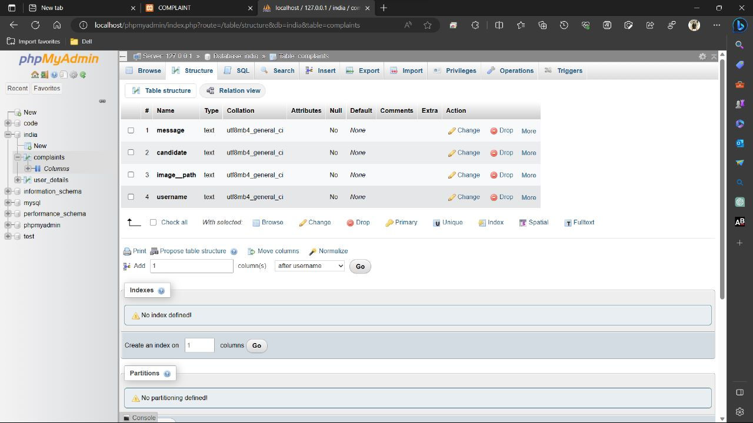

**Figure 4.1.1 complaints table**

### CHAPTER 5

**DATA FLOW DIAGRAM**

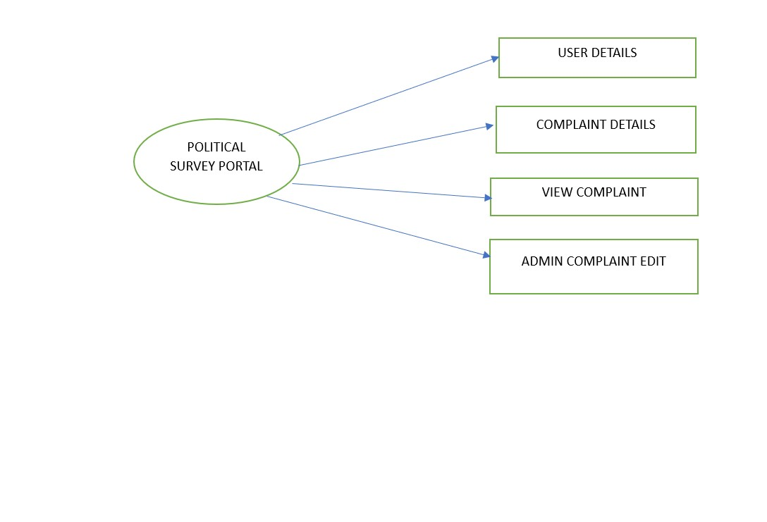

### Screenshots

**Home Page**

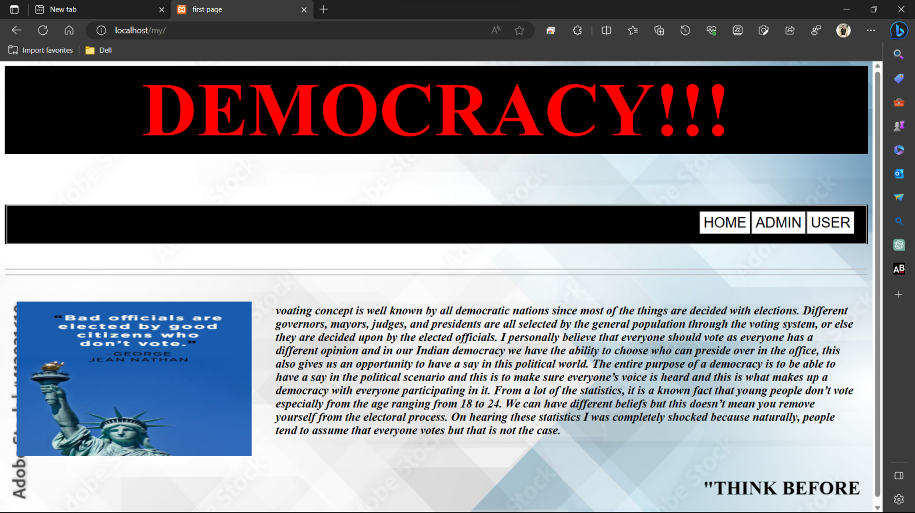

## CHAPTER 6 SAMPLE OUTPUT

#### 

#### Fig 5.1.1Welcome page

**Login page**

**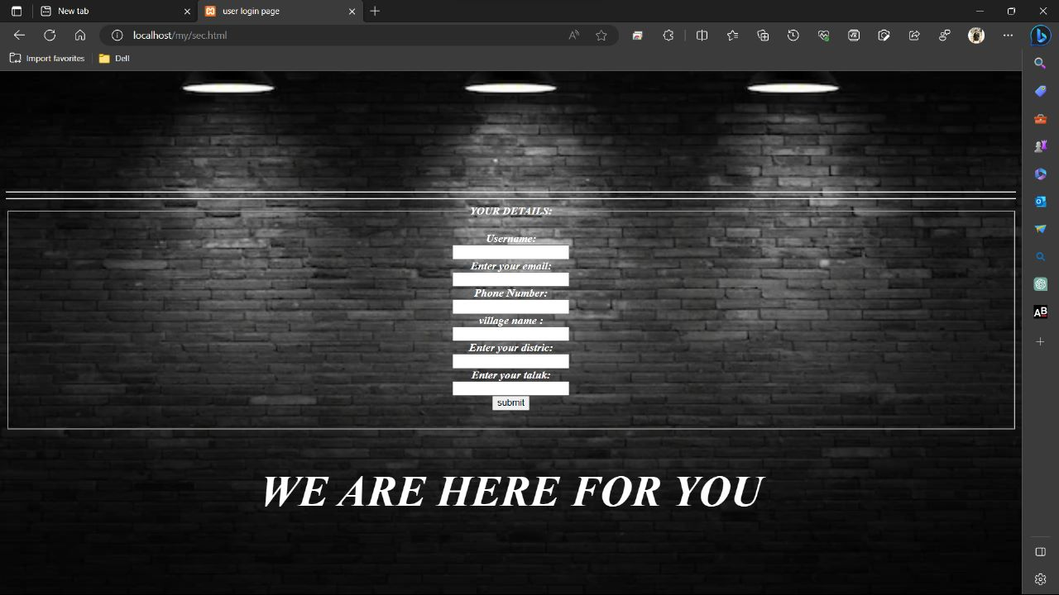**

#### Fig 6.1.2 Login details

In this figure, users can get the information about the course acticities.

**Admin page**

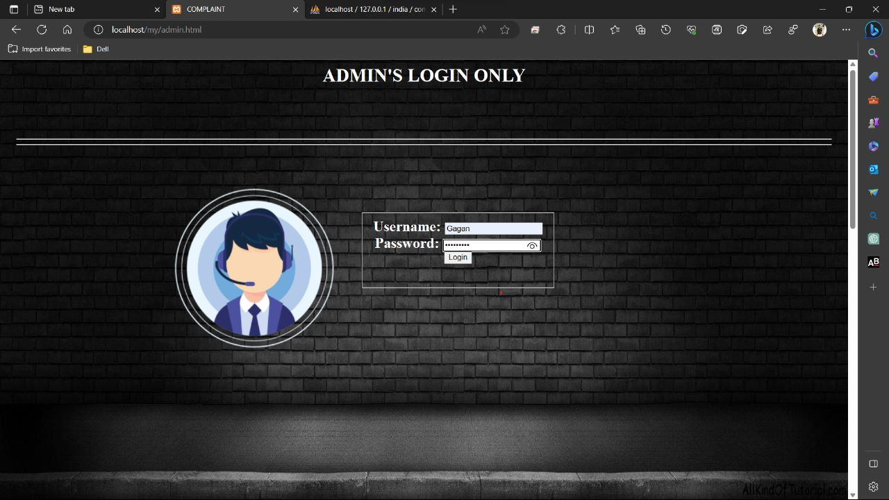

## Complaints details page

## 

## view complaints

## complaints editing page

## admin complaints view page

## CHAPTER 7

## CONCLUSION AND FUTURE WORK

In conclusion Political Survey Portal, the development and implementation of a political survey portal can be a valuable tool in gathering data and insights about people's political opinions and preferences. Such a portal allows individuals to participate in surveys, express their viewpoints, and contribute to the overall understanding of public opinion on political matters. By providing a user-friendly interface and ensuring data privacy and security, the political survey portal can attract a diverse range of participants, leading to a more representative sample and enhancing the reliability of the collected data. The portal's features, such as customizable survey options, real-time data analysis, and visualizations, enable researchers, policymakers, and political organizations to gain valuable insights and make informed decisions based on the survey results.

## CHAPTER 8

**REFERENCE**

1. [www.w3schools.com](http://www.w3schools.com/)
2. [www.php.net](http://www.php.net/)
3. [www.YouTube.com](http://www.youtube.com/)
4. [www.quora.com](http://www.quora.com/)
5. [www.Wikipedia.org](http://www.wikipedia.org/)
6. RamezElmasri and Shamkant B. Navathe, 7th edition, 2017, Pearson